**Industries CPQ: Overview**

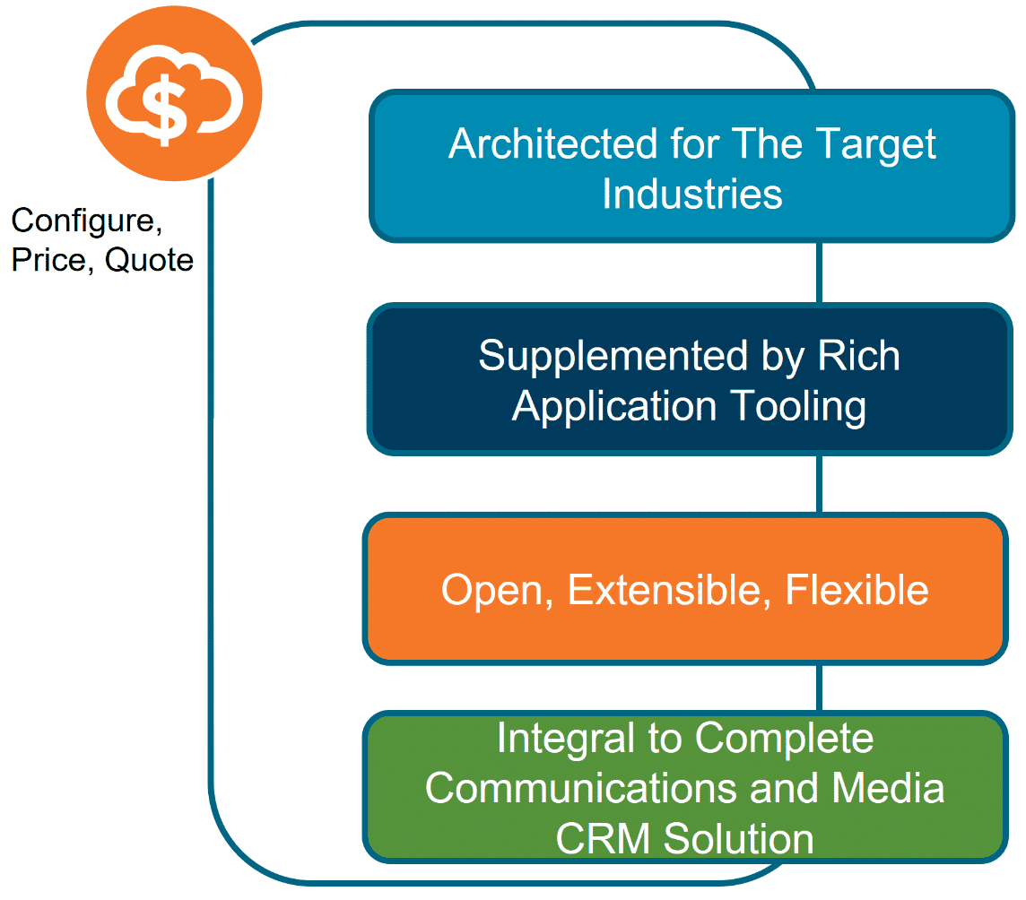

Industries Configure, Price, Quote (CPQ) is a cloud-based, quote-and-order-capture system that is built natively and additively on the Salesforce platform. It enables the configuration of product offers that are just right for the customer. Driven by underlying EPC product-service-resource (PSR) data, Industries CPQ gives sales teams advanced order-capture and guided-selling capabilities so that they can offer best-fit products and services to customers across different channels.

**Business Challenges of CPQ**

In trying to increase sales with CPQ systems, companies have several challenges, for example:

* **Too much time quoting:**Sales agents often spend too much time creating quotes instead of submitting orders, with legacy CRM and custom quoting systems slow to generate quotes.
* **A multitude of product variations:**Businesses have thousands, sometimes millions of product SKUs (stock keeping units) due to numerous and complex products, presenting countless complexities for CPQ systems.
* **Inconsistency across channels:**Companies want to sell product offers based on the same product data through different channels, yet struggle to provide consistent and accurate quotes across different channels, resulting in order fallout and lost business.
* **Demand for personalization:**Customers want quotes for best-fit products based on product availability, alongside their personal preferences and eligibility. Making this contextual information available to sales agents has proven challenging for CPQ systems.

**How Industries CPQ Solves CPQ Challenges**

* **Challenge:**  Produce accurate quotes
  + **Solution:** Ensure availability and serviceability of products in addition to customer eligibility.
* **Challenge:**  Accelerate order capture
  + **Solution:** Maximize customer orders with guided quote configuration and order capture.
* **Challenge:** Reduce order fallout
  + **Solution:** Enforce business rules to validate the configuration specified during order capture, minimizing the possibility of invalid orders.
* **Challenge:** Improve sales processes
  + **Solution:**Provide flexible, configurable sales guidance based on your sales and approval processes and industry best practice
* **Challenge:**Expedite time-to-market
  + **Solution:**Enable quick update of products and promotions in response to market changes.

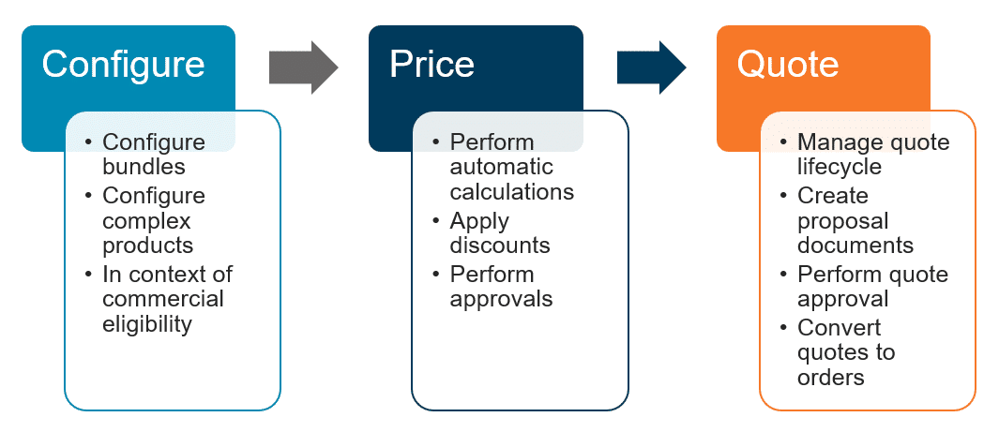

**More About Industries CPQ**

**Key Features**

* Improve usability with a consistent UI and seamless functioning across marketing, sales and services.
* Better than pre-integrated, due to construction using standard Salesforce objects: Opportunity, Quote, Order, Asset. Syncing of Force.com ISV custom objects is not required.
* Build once, deploy everywhere with inherent omnichannel Industries CPQ.

**Rich Application Tooling**

* Improve up-sell and ensure accurate, valid orders with guided selling.
* Communications service console, tuned for high-volume, high-complexity CPQ processes, that drives efficiency and reduces operational expenditure.
* Click-stream tracking provides insight to selling success and failure.

**Openness and Flexibility**

* Meet the varied and changing needs of service providers operating in a complex application and IT ecosphere.
* Work with co-existence-ready, easy-to-integrate external business logic and data.
* Accelerate custom needs development with the interface / implementation paradigm.

**Context Awareness**

* Using EPC as the single source of truth for the underlying PSR data, Industries CPQ integrates process flows with external systems and a powerful rules engine to support the order-capture cycle, for example to:
  + Perform a customer credit check or facility check.
  + Apply any promotions or discounts for which the customer is eligible.
  + Run any other applicable rules toward ensuring the perfect order.

**Industry-Focused Architecture**

* Purpose-built for your industry.
* Designed with product administrators in mind, with natural language rules, visual administration, and reusable componentized rules definition.
* Performance tested at carrier-grade scale

**Interface Implementations**

The core of our open architecture is the interface-and-implementation paradigm.

* An interface is a call out to business logic, and an implementation is the business logic itself.
* For example, if a pricing interface asks the system, “How much do these items cost?”, the implementation responds with the price of the items.

Your Industry Cloud provides multiple options for each process and interface, so you can:

* Choose an existing implementation that best fits your business needs.
* Build your own implementation using Apex.
* Develop a hybrid implementation.

**Lead-to-Cash: Typical Process Flow**

The diagram below shows the typical flow of tasks from the generation of a lead to the start of the customer billing cycle and subsequent customer care. Using Industries CPQ, the order-capture process enables the creation of a quote as input to order management systems. A typical lead-to-cash flow involves each of the stages shown below.

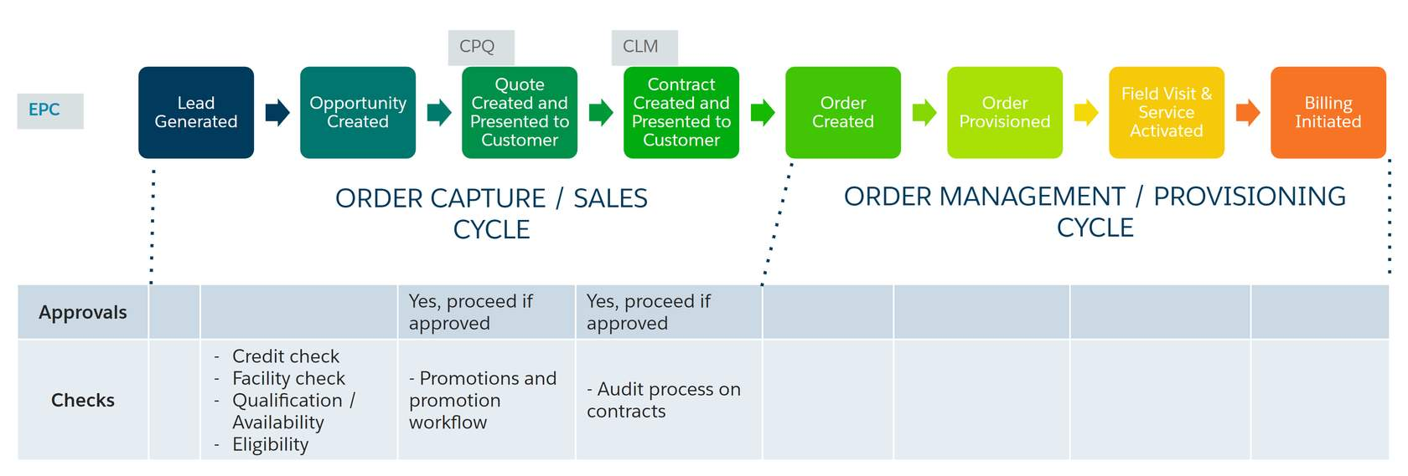

# Order Capture and the Cart

# The Objective of Order Capture

With our order-capture capabilities, you can ensure accurate orders on the way to submitting the perfect order for the customer. Industries CPQ applies business rules to ensure that products and services presented to the customer for purchase are:

* Available to the consumer or business account.
* Items for which the customer is eligible.
* Priced accurately.
* Compatible with any existing products and services held by the customer account.



The Cart is the shopping-cart UI provided with Industries CPQ. Developed using the Vlocity Card Framework, you can modify the appearance and behaviour of the cart to customize it according to your specific business requirements. The Vlocity Card framework provides configurable cards, layouts, and templates, which are UI building blocks included out-of-the-box with the Industries CPQ managed package.

# Pricing, Promotions, and Rules

**Pricing**

Industries CPQ gives you a component-based pricing system with reusable items, such as charges, discounts, adjustments, and penalties. Pricing components are independent of products and allow seamless transitioning to new pricing structures to minimize expense and disruption.

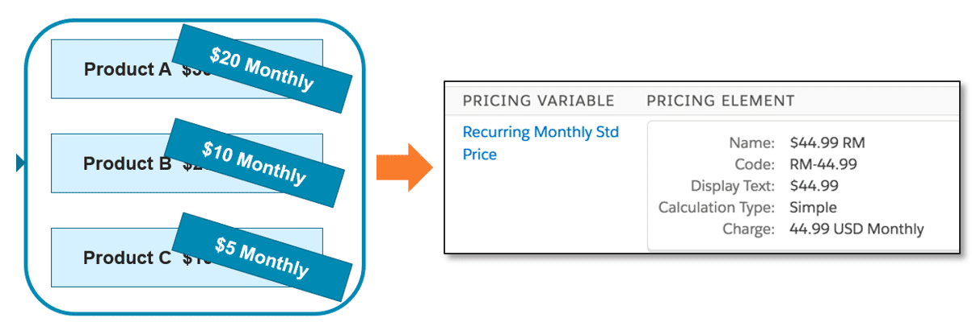

On a daily basis, your company faces many pricing challenges that include:

* Grouping products together, yet also keeping them separate.
* Discounting individual products in a bundle without changing the base price of individual products when purchased separately.
* Limiting product discounts to a specific time frame.
* Pricing products differently for different customer groups.
* Assigning costs as well as charges to products.
* Applying penalties when subscription commitments are broken.
* Providing customers with the option of paying for some products with loyalty points.

**Promotions**

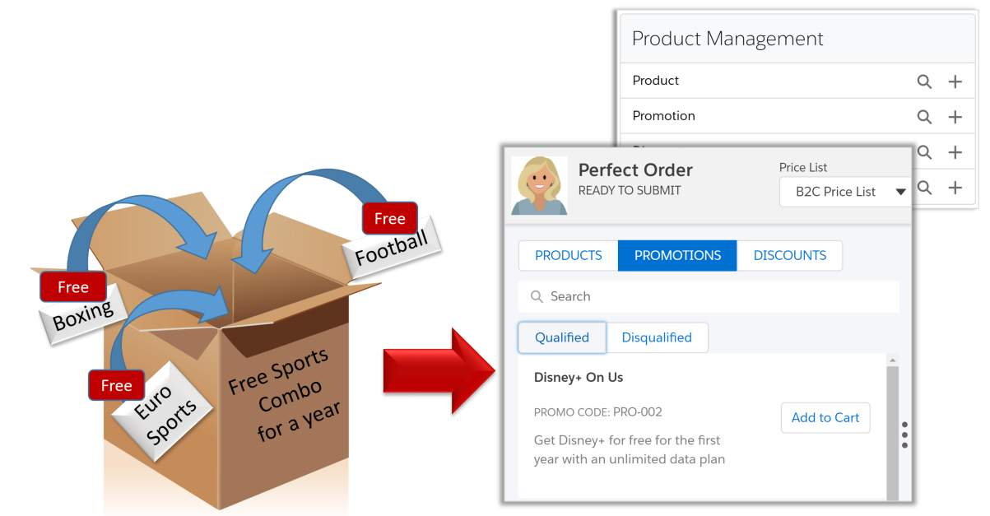

You can use the Product Console to create and maintain promotions and discounts. Promotions is a separate module that provides greater flexibility and automated functionality for product promotions and discounts. With Promotions:

* Each bundled product you have created can remain intact. Any promotion you create can apply to the product without altering it.
* You can apply multiple promotions to one bundle.
* You can apply discounted prices in a promotion to existing assets.
* You can create contractual and transactional discounts.
* Any cardinality changes made to child products within a promotion do not require a refresh of the product hierarchy.

**Rules**

**Rules ensure that:**

* Every order is a perfect order.
* The right products and promotions are available to customers at the right price.
* The appropriate penalties for product or service changes and cancellations are applied

# Guided Selling

Guided Selling allows you to integrate the wealth of Industries CPQ functionality into a seamless, omnichannel digital experience. Guided selling is a consistent shopping experience that includes steps to guide the user through the process of recommending, selecting, and ordering products.

Guided Selling is built on the powerful OmniScript technology. OmniScripts allow you to design engaging customer interactions using a drag-and-drop design tool.

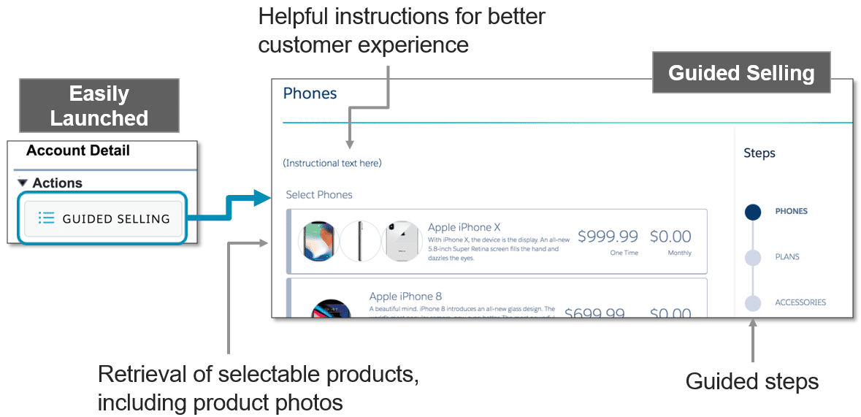

**Call Scripting**

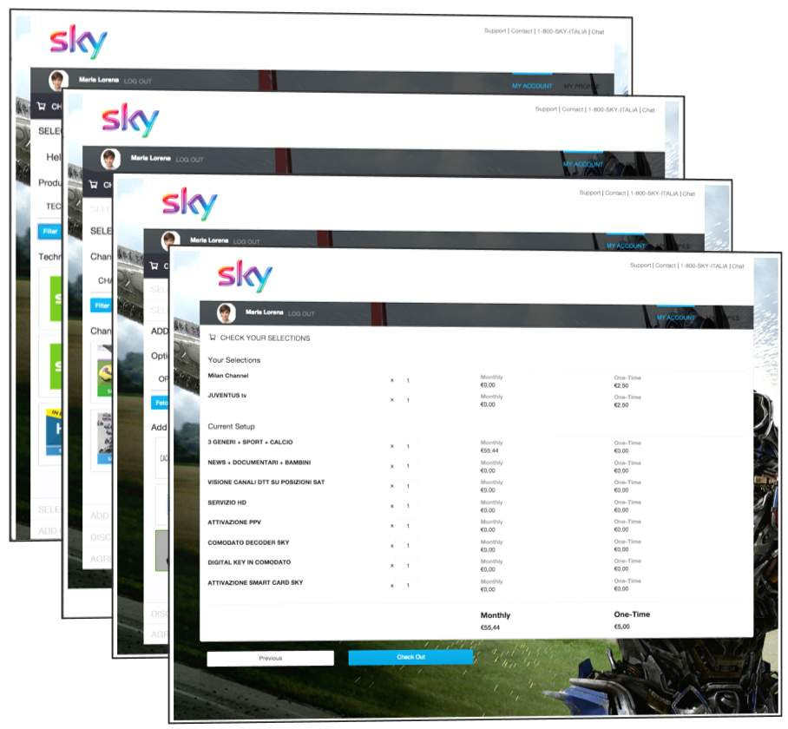

With Industries CPQ, you create guided-selling processes that:

* Craft dynamic customer interactions without the need to develop code, with interactions running on multiple channels and devices.
* Guide users through sales and service processes with fast, personalized responses and seamless integration to enterprise applications and data.

**With guided selling, you can:**

* **Enable needs analysis:** Make possible the complete exploration of customer needs and drive products based on customer profile and articulated preferences.
* **Reduce average handling time:** Guide customer service reps about the most efficient and effective path to complete orders and ensure order accuracy.
* **Increase NPS:**Through reduced average handling time, ensure best fit services and one-and-done customer calls.

**Guided CPQ**

Use the OmniScript Designer to create guided order-capture processes.

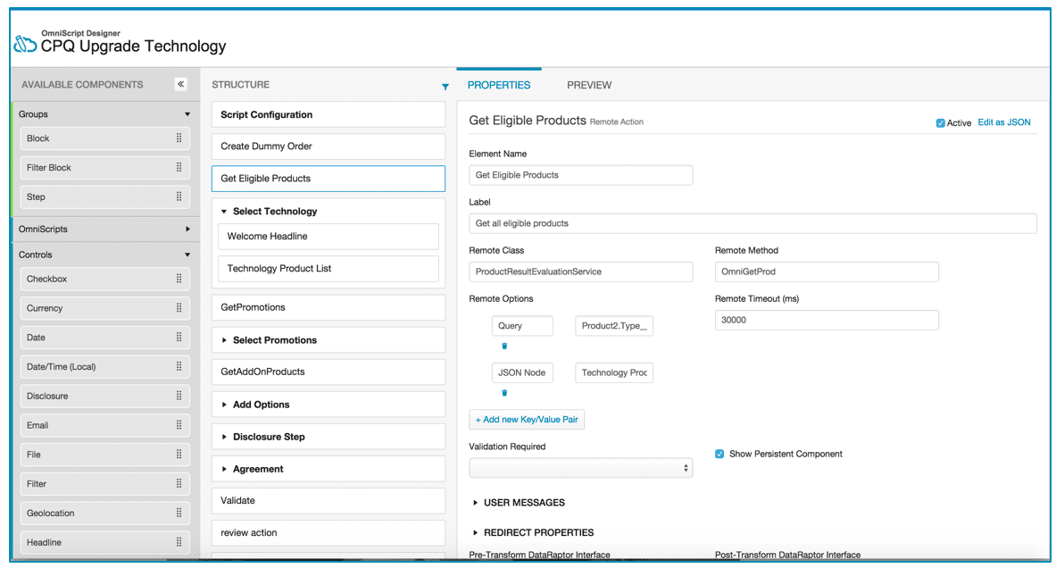

# The Shared Catalog (EPC)

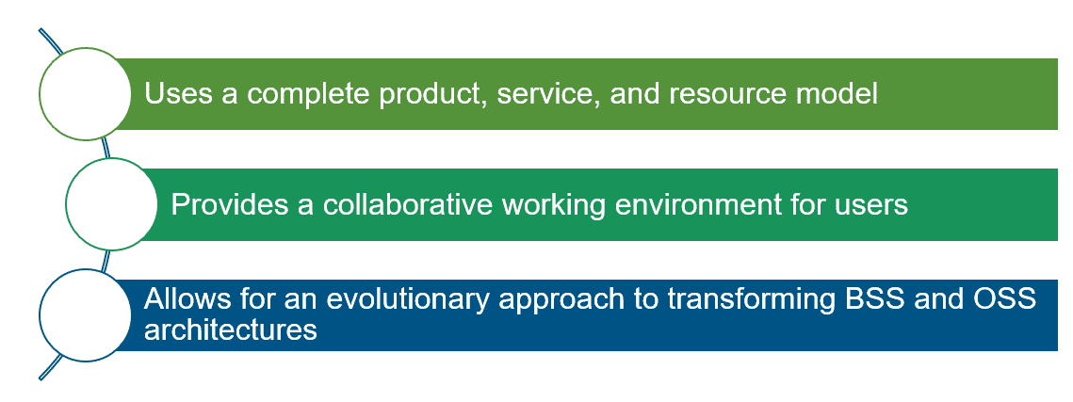

Our Enterprise Product Catalog (EPC) gives your business an industry-leading, catalog-driven platform that revolutionizes the CPQ and order-management space by:

* Using a metadata-driven approach to accommodate all the incarnations of a product as it travels from a twinkle in the eyes of the customer to the physical implementation in the customer’s hands.
* Integrating with your end-to-end ecosystem using a complete product-service-resource (PSR) model to drive sales, configure-price-quote (CPQ), order-management, and order-fulfillment capabilities.
* Using an evolutionary approach to transform both front-office and back-office systems into a master-catalog-driven architecture.

**Core Capabilities of the Shared Catalog**

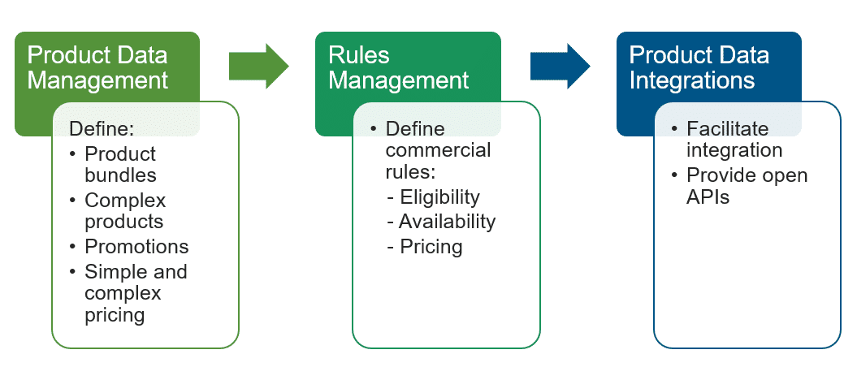

**PSR Layers**

What's in the product layer?

Commercial view of what the business sells

What's in the service layer?

Can include service specs and service configurations, such as a broadband internet service

What's in the resource layer?

May include equipment, such as cable attributes and access ports, typically to support the network